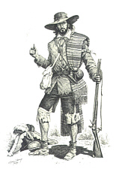
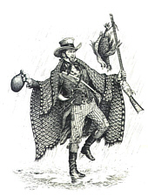

10th Annual, Pre-1840 Texas
January 22, 2011
Smaller graphics from The Texian Iliad, copyrighted by and courtesy of Dr. Stephen Hardin
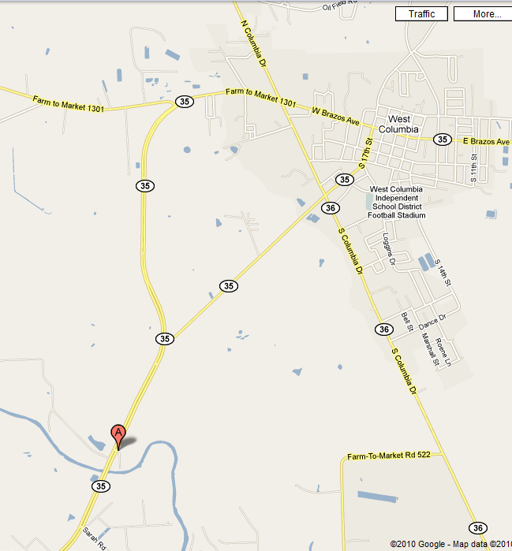
This year we will be at Hanson Riverside County Park (click on link for park site) on the San Bernard River about 3 miles Southwest of W. Columbia, Texas on Hwy 35. This year there will be several speakers giving presentations on early Texas history and lots of camaraderie. There are no requirements for fire pans for camp fires. Wood will be provided by the county. No travel trailers or RVs (there just no space). Water and modern restrooms are available.
Also, be sure to spread the word as the public IS invited to attend.

There is a $10 general registration fee to help defray expenses and period dress is not required, but it is encouraged.
For more info, contact Col. Jerry Tubbs at 713-806-8924 or mailto:coloneltubbs@yahoo.com or
Col. George Rollow at webmaster@texianlegacy.com

