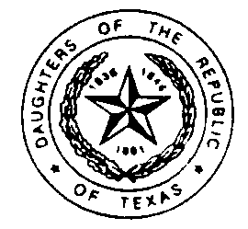
Daughters of the Republic of Texas

Join us for the second
French Legation - DRT Headquarters - Republic of Texas Museum
Texas History Forum
March 5, 2005
at the Republic of Texas Museum, 510 East Anderson Lane, Austin, Texas
Registration is $25, and includes lunch and a tour of the Republic of Texas Museum

Guest sign in begins at 9:00 am. The program begins at 9:30 with a welcome by
DRT Historian General Elaine Milam Vetter, the French Legation Committee and
the Republic of Texas Museum Committee.
Speakers include:
- Gary Hartman, Professor at Texas State University, will speak on the history of Texas Music
- Jack Judson, from the Magic Lantern Castle Museum, will speak on "Magic Lanterns"
- Steve Tomka from the University of Texas at San Antonio Center for Archaeological Research who will speak on the findings of the dirt from under the Alamo Gift Museum
- Joan Kilpatrick from the Texas General Land Office who will speak on conservation of Texas maps

For more information, please contact:
The French Legation Museum: 512-472-8180, email: drt_museum@sbcglobal.net
Or: DRT headquarters/Republic of Texas Museum: 512-339-1997
To register make checks payable to: DRT Inc., Austin History Forum, and remit to:
Pat Horridge, 7207 Waterline Rd., Austin, TX 78731

Registration Form

Name:

Mailing Address:

City: State: Zip:

Telephone: E-mail:

